Hi Sam,
I’m Sorry as I’m not explanative in my previous attempts for this question. The following is the table visual how it should be.
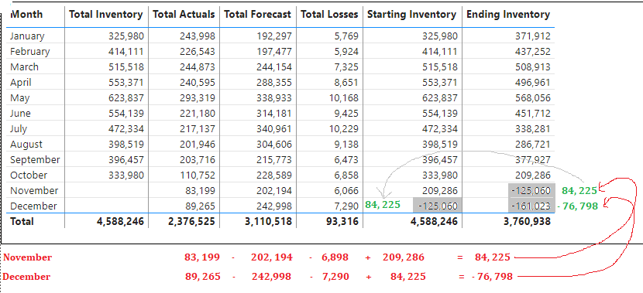
As of today, Nov’19 and Dec’19 are the months we don’t have data.
- Nov’19 month will be available in first week of December 2019.
- Dec’19 month will be available in first week of January 2020.
If the data is not available in Total Inventory i.e. in this case November, the following are the steps to be performed.
- Ending Inventory for previous month (Ending Inventory for Oct’19) i.e.209, 286 should be loaded into for Nov’19.
- Now, the should be calculated like below
- As, the December month Total Inventory is not available, Ending Inventory for November should be loaded into for Dec’19 i.e. 84, 225.
- Now, the for Dec’19 should be calculated like below

Similarly, this will be implemented for 2020.

This is iterative process as long as there are no values in the Total inventory measure. Initially I used the following to get the Circular dependency.
measure uses measure
measure uses measure
measure uses measure.
Thanks
Satya

