Data Analysis Challenge 05 - Tip Analysis
import numpy as np
import pandas as pd
import matplotlib.pyplot as plt
plt.rcParams["figure.facecolor"] = "white"
url = "https://raw.githubusercontent.com/guipsamora/pandas_exercises/master/07_Visualization/Tips/tips.csv"
df = pd.read_csv(url)
df.head(10)
 | Unnamed: 0 | total_bill | tip | sex | smoker | day | time | size
0 | 0 | 16.99 | 1.01 | Female | No | Sun | Dinner | 2
1 | 1 | 10.34 | 1.66 | Male | No | Sun | Dinner | 3
2 | 2 | 21.01 | 3.50 | Male | No | Sun | Dinner | 3
3 | 3 | 23.68 | 3.31 | Male | No | Sun | Dinner | 2
4 | 4 | 24.59 | 3.61 | Female | No | Sun | Dinner | 4
5 | 5 | 25.29 | 4.71 | Male | No | Sun | Dinner | 4
6 | 6 | 8.77 | 2.00 | Male | No | Sun | Dinner | 2
7 | 7 | 26.88 | 3.12 | Male | No | Sun | Dinner | 4
8 | 8 | 15.04 | 1.96 | Male | No | Sun | Dinner | 2
9 | 9 | 14.78 | 3.23 | Male | No | Sun | Dinner | 2

1. Delete the Unnamed 0 column
df = df.drop(columns=["Unnamed: 0"])

2. Plot the total_bill column histogram
total_bill_values = df["total_bill"]
fig, ax = plt.subplots(nrows=1,ncols=1,figsize=(10,5))
ax.hist(total_bill_values, bins = 10, density=False)
ax.set_title("Histogram of total bills")
ax.set_xlabel("Total bill")
ax.set_ylabel("Frequency")
plt.show()
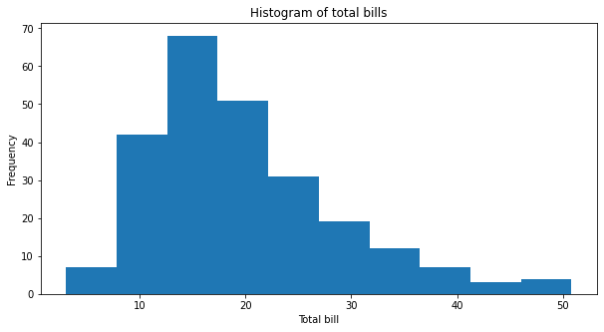
Figure 1: A histogram with frequency of total bill values

3. Create a scatter plot presenting the relationship between total_bill and tip
tips = df["tip"]
fig, ax = plt.subplots(nrows=1,ncols=1,figsize=(10,5))
ax.scatter(x=total_bill_values,y=tips)
ax.set_title("Relationship between total bills and tips")
ax.set_xlabel("Total bill")
ax.set_ylabel("Tips")
plt.show()
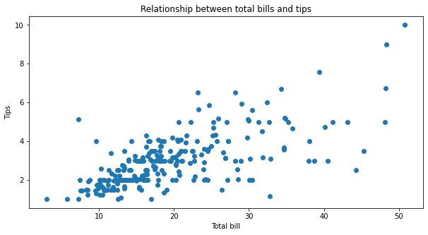
Figure 2: A scatter plot to display relationship between total bill values and tips

4. Create one image with the relationship of total_bill, tip and size.
fig, ax = plt.subplots(nrows=1,ncols=1,figsize=(10,5))
ax.scatter(x=total_bill_values,y=tips, c=df["size"])
ax.set_title("Relation ship bewteen total bill, tips and size")
ax.set_xlabel("Total bill")
ax.set_ylabel("Tips")
plt.show()
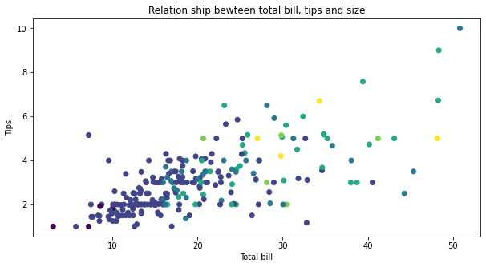
Figure 3: A scatter plot to display relationship between total bill, tips adn size

5. Present the relationship between days and total_bill value.
sunday_data = np.array(df[df["day"] == "Sun"]["total_bill"])
saturday_data = np.array(df[df["day"] == "Sat"]["total_bill"])
Thursday_data = np.array(df[df["day"] == "Thur"]["total_bill"])
Friday_data = np.array(df[df["day"] == "Fri"]["total_bill"])
total_bill_days = [sunday_data, saturday_data, Thursday_data, Friday_data]
labels = df["day"].unique()
fig, ax = plt.subplots(nrows=1,ncols=1,figsize=(10,5))
ax.boxplot(x=total_bill_days,labels=labels)
ax.set_title("Relationship between days and total bill")
ax.set_xlabel("Days")
ax.set_ylabel("Total bill")
plt.show()
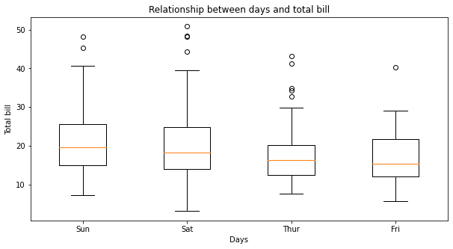
Figure 4: Displaying relationship between total bill and days

6. Create a scatter plot with the day as the y-axis and tip as the x-axis, differ the dots by sex
fig, ax = plt.subplots(nrows=1,ncols=1,figsize=(10,5))
ax.scatter(y=df["day"],x=df["tip"])
ax.set_title("Tips on given day")
ax.set_xlabel("Tips")
ax.set_ylabel("Days")
plt.show()
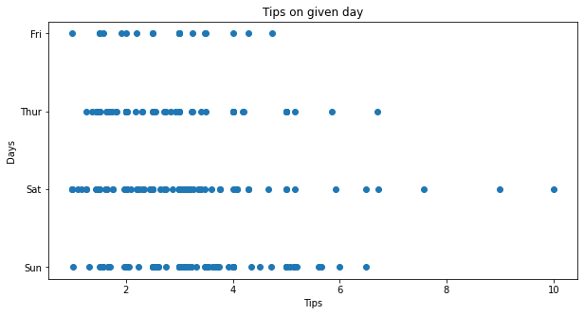
Figure 5: Scatter plot with tips and days

7. Create a box plot presenting the total_bill per day differentiation the time (Dinner or Lunch)
#Prepare data for box plot
dinner_data = np.array(df[df["time"] == "Dinner"]["total_bill"])
lunch_data = np.array(df[df["time"] == "Lunch"]["total_bill"])
total_bill_time = [dinner_data, lunch_data]
time_labels = df["time"].unique()
fig, ax = plt.subplots(nrows=1,ncols=1, figsize=(10,5))
ax.boxplot(x=total_bill_time,labels=time_labels)
ax.set_title("Relation ship between time and total bill")
ax.set_xlabel("Time")
ax.set_ylabel("Total bill")
plt.show()
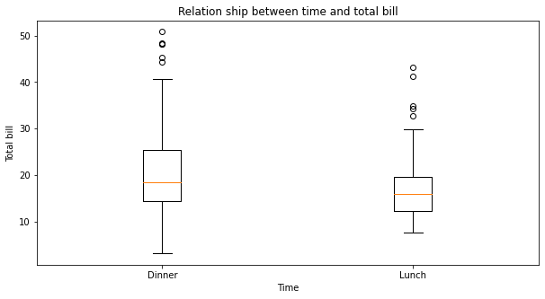
Figure 6: Displaying relationship between total bill and time

8. Create two histograms of the tip value based for Dinner and Lunch. They must be side by side
dinner_tip_data = np.array(df[df["time"] == "Dinner"]["tip"])
lunch_tip_data = np.array(df[df["time"] == "Lunch"]["tip"])
total_bill_time = [dinner_data, lunch_data]
fig, ax = plt.subplots(nrows=1,ncols=2, figsize=(15, 5))
ax_lunch = ax[0].hist(x=lunch_data, bins=10)
ax[0].set_title("Tips during lunch")
ax[0].set_xlabel("Tips")
ax[0].set_ylabel("Frequency")
ax_dinner = ax[1].hist(x=dinner_data,bins=10)
ax[1].set_title("Tips during dinner")
ax[1].set_xlabel("Tips")
ax[1].set_ylabel("Frequency")
plt.show()
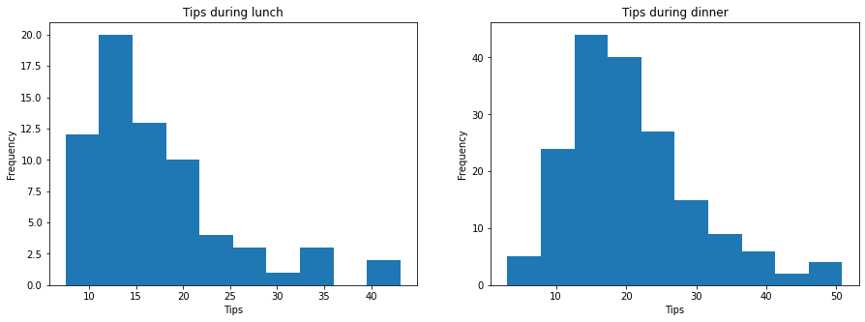
Figure 7: Displaying values of tips during lunch and dinner

9. Create two scatterplots graphs, one for Male and another for Female, presenting the total_bill value and tip relationship, differing by smoker or no smoker
#Prepare data for scatter plot
male_bill_tip = df[df["sex"]=="Male"]
female_bill_tip = df[df["sex"]=="Female"]
labels_sex = df["sex"].unique()
fig, (ax_male, ax_female) = plt.subplots(nrows=1, ncols=2, figsize=(15, 5))
# Male scatter plot with trendline and R value
x_male = male_bill_tip["total_bill"]
y_male = male_bill_tip["tip"]
ax_male.scatter(x_male, y_male)
ax_male.set_title("Relationship between total bill and tips in males")
ax_male.set_xlabel("Total bill")
ax_male.set_ylabel("Tips")
z_male = np.polyfit(x_male, y_male, 1)
p_male = np.poly1d(z_male)
ax_male.plot(x_male, p_male(x_male), "r-")
r_male = np.corrcoef(x_male, y_male)[0, 1]
ax_male.text(0.05, 0.95, f"R = {r_male:.2f}", transform=ax_male.transAxes, ha='left', va='top')
# Female scatter plot with trendline and R value
x_female = female_bill_tip["total_bill"]
y_female = female_bill_tip["tip"]
ax_female.scatter(x_female, y_female)
ax_female.set_title("Relationship between total bill and tips in females")
ax_female.set_xlabel("Total bill")
ax_female.set_ylabel("Tips")
z_female = np.polyfit(x_female, y_female, 1)
p_female = np.poly1d(z_female)
ax_female.plot(x_female, p_female(x_female), "r-")
r_female = np.corrcoef(x_female, y_female)[0, 1]
ax_female.text(0.05, 0.95, f"R = {r_female:.2f}", transform=ax_female.transAxes, ha='left', va='top')
plt.show()
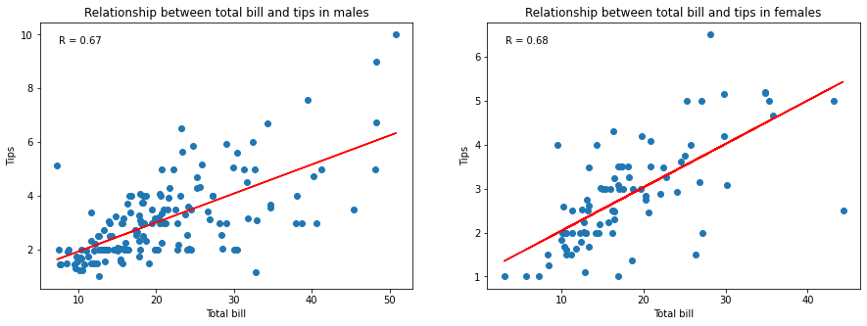
Figure 8: Exploring correlation between total bills and tips based on sex

