MEMBERSHIP TALLY Retrospective Analysis
Requirement(s):
- Provide ability to give the current member count based on the date selected i.e., both current and historically at any point in time a month is selected
- A member upon joining can be of benefit “Paid Type” - PAID or Free
- At any point after joining they may change their membership as follows:
  - NEW JOINER: New person joining as either a Free or Paid member
  - UPGRADE: Free->Paid
  - DOWNGRADE: Paid->Free
  - RENEWAL: Paid->Paid
  - CLOSURES: Existing member (Free or Paid) closing account
  - or just stay as is on Free indefinitely until as and when they close their membership
- Need to be able to display something like below:
Month Selected: JUL 2019
Paid Type | Opening Bal | New Joiners | Upgrades | Downgrades | Renewals | Closures | Closing Balance
Free | 10 |  |  | 1 |  |  | 9
Paid | 20 |  | 1 |  |  |  | 21

- As well as being able to filter above by Mth/Year we also need to establish “engagement” of a member being ACTIVE | INACTIVE
- Activity will be deemed ACTIVE if in the last 3 years from the date selected (month/year) the member has triggered an “event” in the [Activities] table
I have access to source system and have extracted the following data:
- [Member]
  - dimension containing the unique member accounts
  - currently around ~700K members in this table
  - snapshot below showing for 3 members:
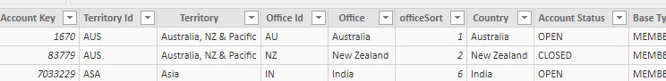
- [Benefits]
  - fact table containing the history of above members with from/to dates since joining and altering their type of membership
  - currently around 1.2 million rows of data
  - snapshot below showing for the above 3 members:
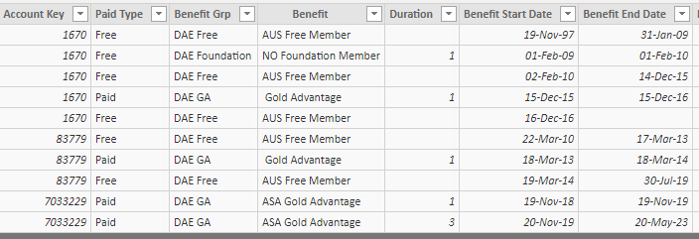
- [Activities]
  - fact table containing the history for each member of the date a member performed a particular event i.e., this is to gauge if after joining they actually purchase something or do some event to highlight engagement vs dormant members that haven't done anything or did then stopped etc.,
  - Over 5.6 million rows for this so far
  - Snapshot of activities for above 3 accounts (total of 428 activity rows for above 3 members)
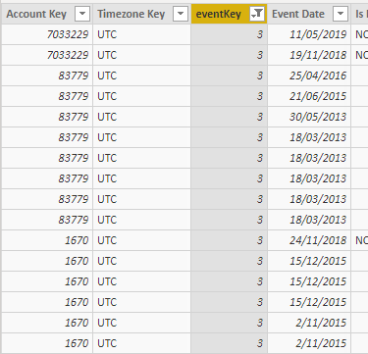
- [Event]
  - Dimension table containing event details
  - Below are all the values:
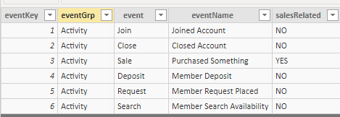
NB:- joining is considered an activity but closing is not but still record here for reference

DATA MODEL setup so far:
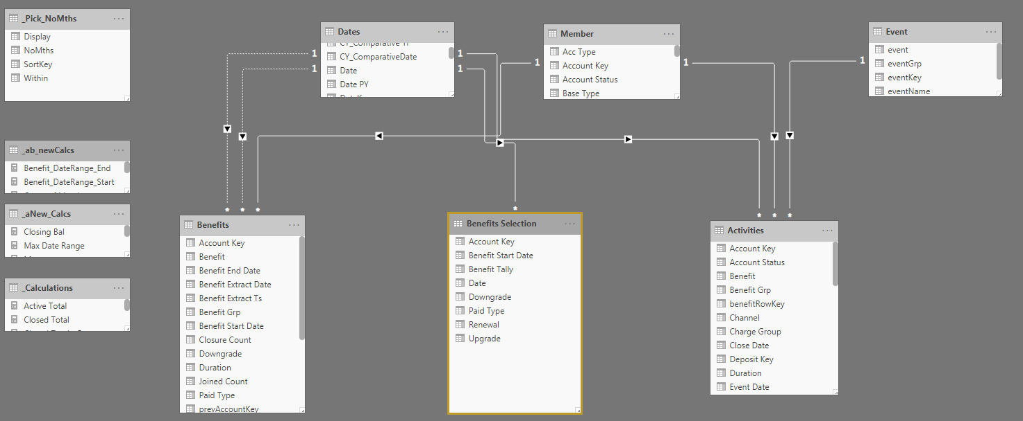

NB: Benefits, table I’ve manipulated in Power Query to determine if benefit line entry is UPGRADE | DOWNGRADE | RENEWAL
Attempt so far:
- I tried to create a table called “Benefits Selection” where it joins all of the ‘Dates’ with ‘Benefits’ so that on any date selected I can determine which benefit membership exists
- But getting stuck plus don’t wish to store ‘Benefits Selection” since currently just on testing 3 accounts volumes are manageable but later when all accounts + benefits in mix the cartesian product will be ~121 million rows
Trying to think about how to do this on-fly calculation but hence why I need your assistance/guidance please

