The objective is effectively a COUNTIF for the three Count v2 values resulting in:
No Change = 2
Increase = 3
Decrease = 3
Thus, the unique Product IDs where orders exist in the YTD and PYTD time frames are 7.
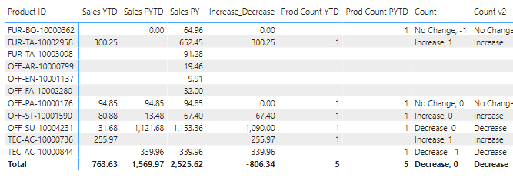

I’m looking for each count of distinct values derived (No Change, Increase, Decrease, Total) to be available in a Card visualization. I’m just not clear on whether I need the visualization to be treated as a summarization table, or how DAX measures ultimately produce the COUNTIF results of the above matrix visualization.

As mentioned, as a second objective, I’d like a variation of a Count v2 measure to reflect ‘No Change’ in the four “blank” YTD / PYTD Product IDs given their Sales PYTD $.

