I have created a year table in excel where the user can select a year from a drop down data validation
I have made a variable in power query for the input year
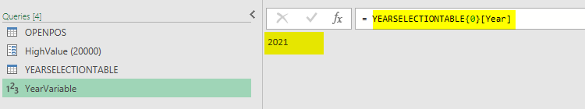
I have put the variable into the filter to narrow the data table to the required year
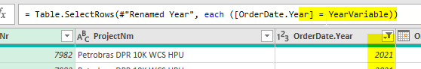
This all works great, but what if I want the user to be able to pick all years, ie that there will be no filter on the column OrderDate.Year for 2021 or any other year?

