PYTD Measure with Custom Fiscal (4-4-5) Calendar

Summary of Results to Date and further detailing of the problem

Max(Orders.Ship Date) all records = 03/25/2020 which is the basis for PYTD logic

‘Standard’ report page:
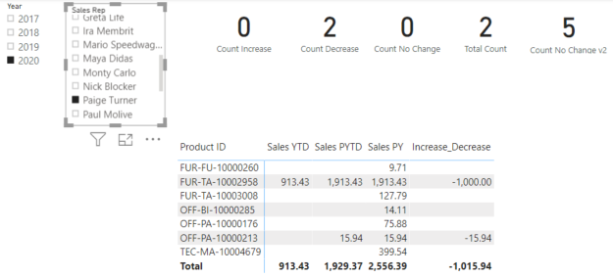
Every about the card and matrix visualizations and their measures are correct.

‘Custom Fiscal’ report page:
This is the attempt to mimic all measures and visualizations on the ‘Standard’ page against a custom 4-4-5 fiscal calendar.
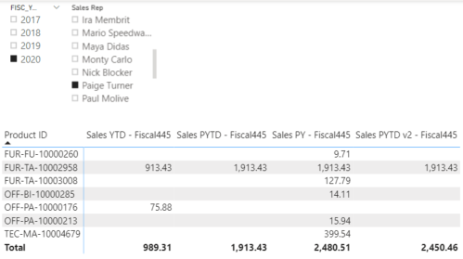
Fiscal Calendar Measures:
‘Sales YTD – Fiscal445’ correctly shows the values for the two Product IDs and the total from the Excel dataset:
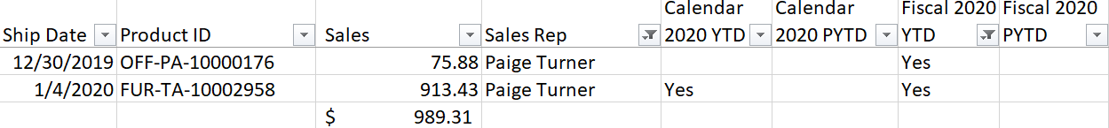

‘Sales PY – Fiscal445’ is also valid and showing expected results.

‘Sales PYTD – Fiscall445’ shows more inconsistent and presumably invalid results:
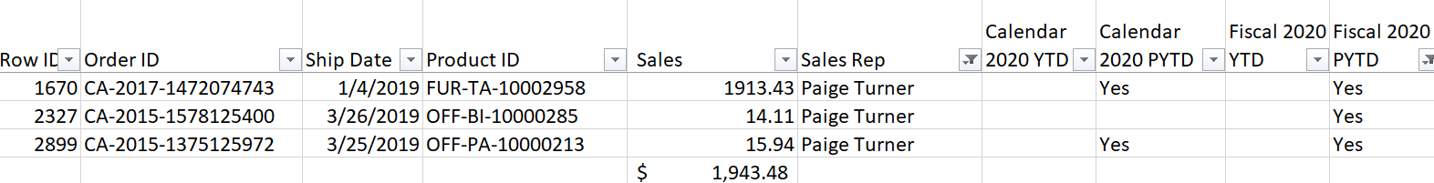
Per the matrix visualization for Paige Turner in fiscal year 2020, all three of these orders should be included in PYTD based on the Fiscal 4-4-5 calendar; yet two of these product IDs and their sales are missing nor included in the total sales.

Let’s look at Anna Sthesia:
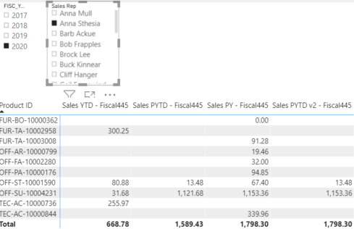

‘Sales YTD – Fiscal445’ correctly shows the values for the four Product IDs (five orders in all) and the total sales.
‘Sales PY – Fiscal445’ is also valid and showing expected results.

‘Sales PYTD – Fiscall445’ shows more inconsistent and presumably invalid results:
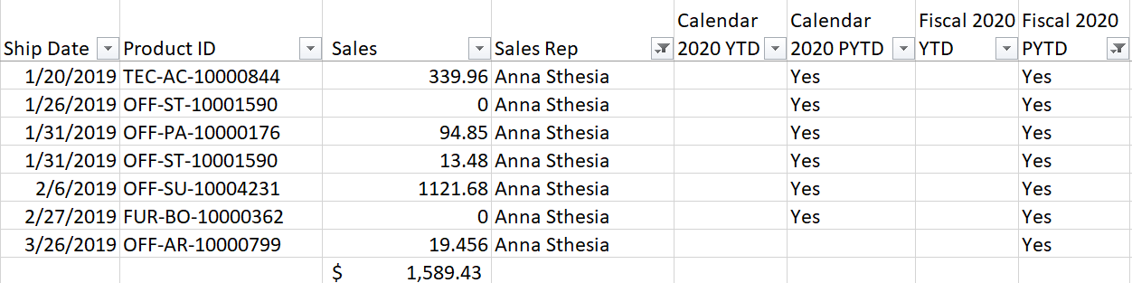
The Sales Totals are correct. However, the Sales by product ID are not displaying for five of the orders [and their five product IDs] above. That seemingly indicates some context issue to resolve, and the condition occurs when no YTD records [in 2020] exist. Yet, since Paige Turner also has Sales missing from her ‘Sales PYTD – Fiscal445’ total, it’s a challenge to see the problem.

