Week Beginning changes to Sunday in the PBI service?
I am working with a slicer that slices by week.
I want to be able to see all the data by week. The weekly slicer contains Mondays and connects my date table to my data table.
The week beginning is designed to be Monday.
Calculating Start of Week
To create the week beginning column in my tables in power query I copy the date columns and then click Transform then date then select week then start of week.
What happens when I push the report to PBI service?
- Initial push the report appears and works as designed in the PBI desktop
- After first refresh the start of the week moves to Sunday.

How do I stop the week beginning shifting to Sunday in my slicer?

Picture 1 -> PBI Desktop Report Design
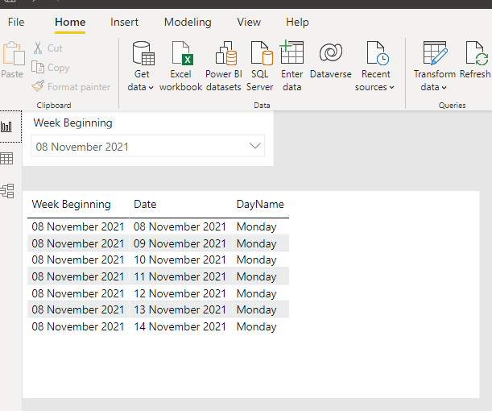

Picture 2 -> Report in PBI service after first Upload
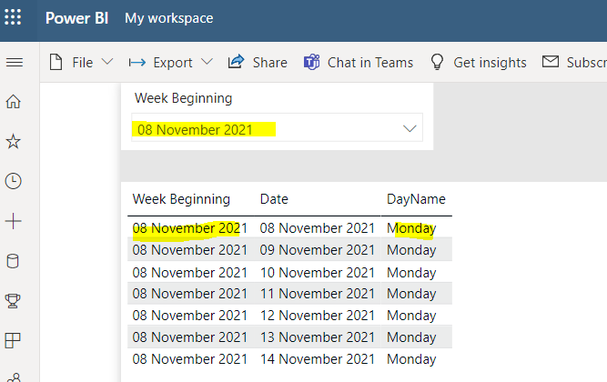

Picture 3 -> Slicer changes to Sundays after first refresh
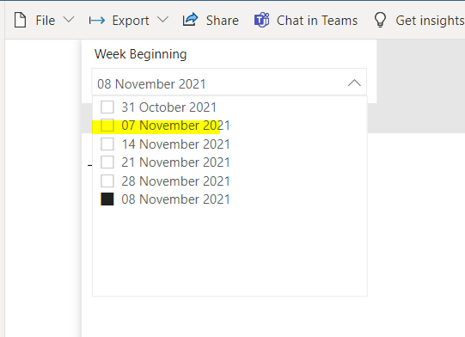

Picture 4 -> Slicer using Monday no longer works
