The following is available in a ‘Direct Query’ connection.

The table visualization reflects the relationship among the Calendar._Calendar Hierarchy.Bill Date column, and measures calculated in the source cube… AOP and Billed Sales.

The objective of the “Refresh Date” is to find the max “bill date” associated with Billed Sales. As you can see, “monthly” AOP data exists through the remainder of calendar 2020 while billed sales data exists weekly through July 17, 2020. Thus, 2020-07-17 is the desired results of Max ( Bill Date ) where Billed Sales > 0.

Note that Bill Date exists in two hierarchies within the Calendar table; the two hierarchies accommodate a standard calendar and a fiscal 4-4-5 calendar.

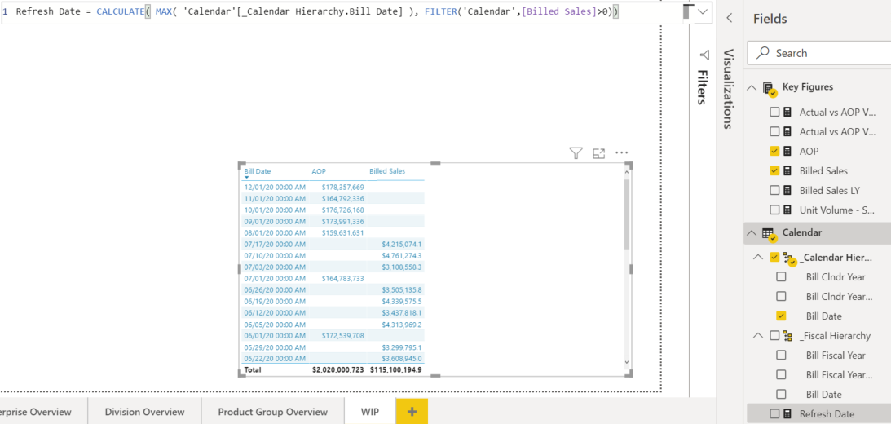



Results are below.

As the Fields pane above shows, I am dealing with an AtScale cube and don’t have a specific Sales fact table with its Bill Date. My ‘Bill Date’ exists in a Calendar table, and the Billed Sales [for a given date] is available in the ‘Key Figures’ table. Thus, I don’t know how to apply a “Billed Sales > 0” filter to the Bill Date in order to produce a max(bill date) = ‘07/17/20’.

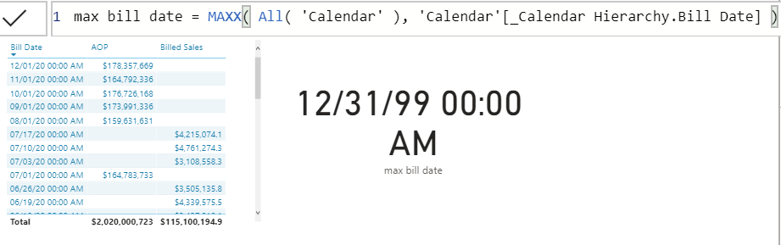

As a secondary issue, since the *max bill date* measure is based on columns in this Direct Query cube, it does not appear that I have an option to format the measure differently. “Date” is not available as a Data Category option.

**Additional Examples**

Sam has a great video on monthly budget allocations by date: <https://www.youtube.com/watch?v=7VKU-dvQv3c>

It is based on having a Sales Budget table having a Month & Year column and joining that to a Dates dim table with the use of the TREATAS function.

In my cube model below, the AOP is already a SUM – an aggregate measure – which associates only to the first Bill Date of each calendar month.

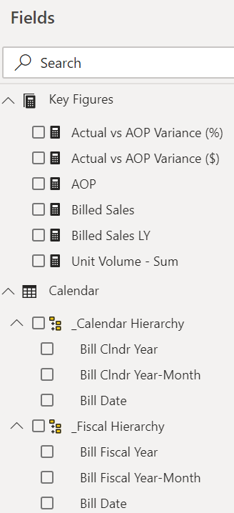

My objective to produce a measure of AOP by Bill Date based on dividing the AOP on the first date of each month by the number of days of each month.

Here’s the new DAX measures which function and display in the table visualization below, but clearly I haven’t figured out how to apply the “AOP Allocation by Date” to every date in the month:

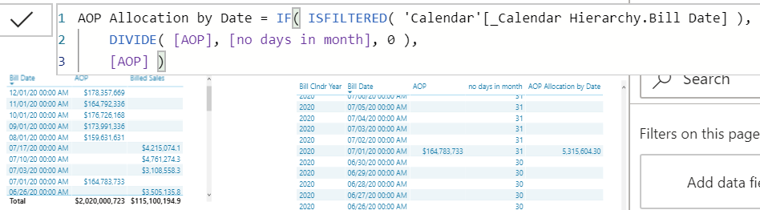

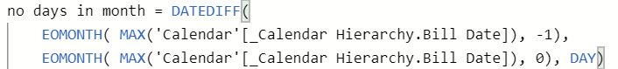

Simple non-Date DAX Measure

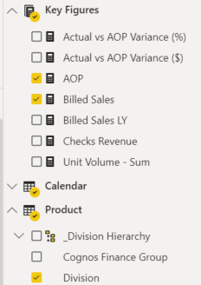

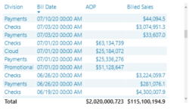

This new measure breaks the above visual:

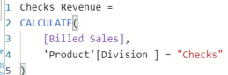

And does not work in a simple card:



What about having Billed Sales as a cube measure makes it so problematic when new measures are needed?