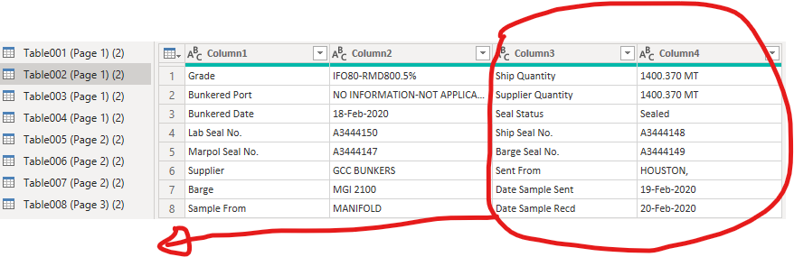

How can I bring down Column 3 & 4 under rows (8~16).
Intention: I want to make Column #1 and #3 as my row (heading) so the information in column 2 & 4 will be under the main heading
Example
Grade | Ship Quantity | Bunkered Port | Supplier Quantity | Bunkered Date | Seal Status
IFO80-RMD800.5% | 1400.370 MT | NO INFORMATION-NOT  APPLICABLE | 1400.370 MT | 18-Feb-2020 | Sealed

Followed by, combine the above table with another table side by side

