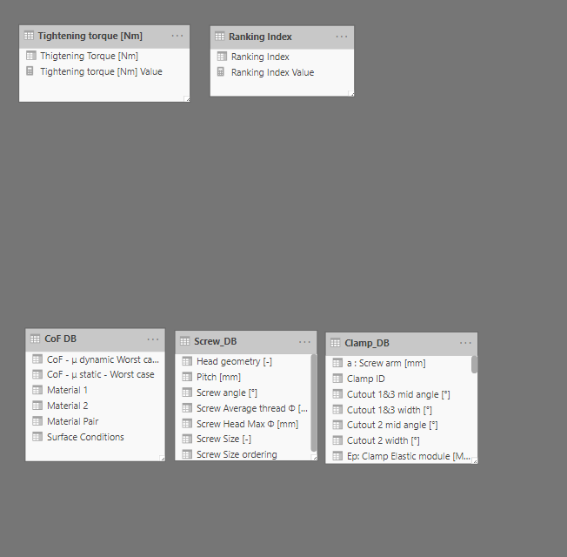

TARGET: plot Tightening Torque (M_{t}) Vs Clamping force (F_{Clamping})
CHALLENGE:
to calculate the correct clamping force I need to calculate the CUMULATIVE of INCREMENTAL Screw force (ΔF_{S}) and INCREMENTAL circumferential force (ΔF_{C})
ΔF_{S} = F_{s j} – F_{s j-1} (“j” = ranking index = tightening torque ranking. For these reasons I need a ranking index)
PROBLEM: the calculation is correct if I plot it over the ranking index and is wrong if I plot it over the tightening torque
WRONG
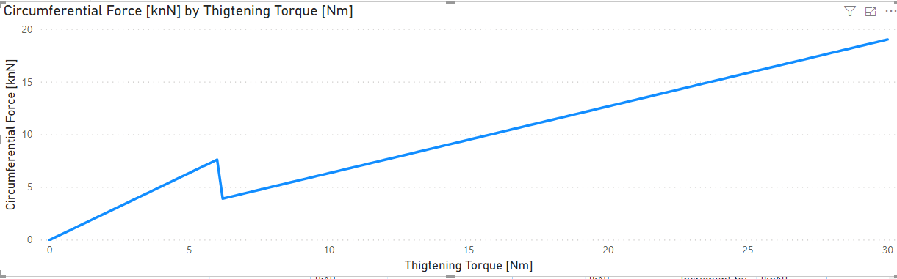

CORRECT
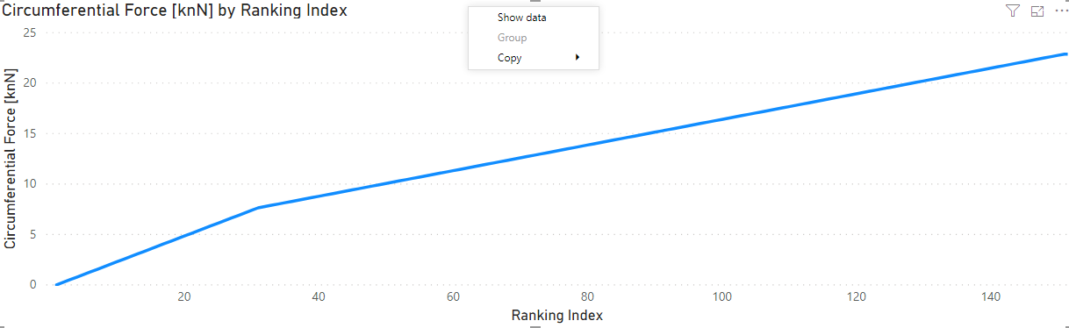

Formulas are below
“Screw Force” at “j” Torque level where 0 <= j <= 200

$$F_{Sj}= \frac{2×M_{tj}}{\left(\frac{p}{\text{π}}+ ɸ_{St}×\frac{μ_{St}}{\cos{β}}+ɸ_{Su}×μ_{Su}\right)}$$
Circumferential Force at “j” Torque

$F_{Cj}= F_{Sj}$ Before head contact condition

$F_{Cj}= {F_{CTj-1}+F}_{S}×HCI$ After head contact condition
Radial Force at “j” Torque

$$F_{Bj}= {2×F}_{Cj}$$

Clamping force at “j” torque

$${F_{clamping j}= F}_{NO}= \frac{F_{Bj}}{2×\tan\left(α/2\right)}$$

