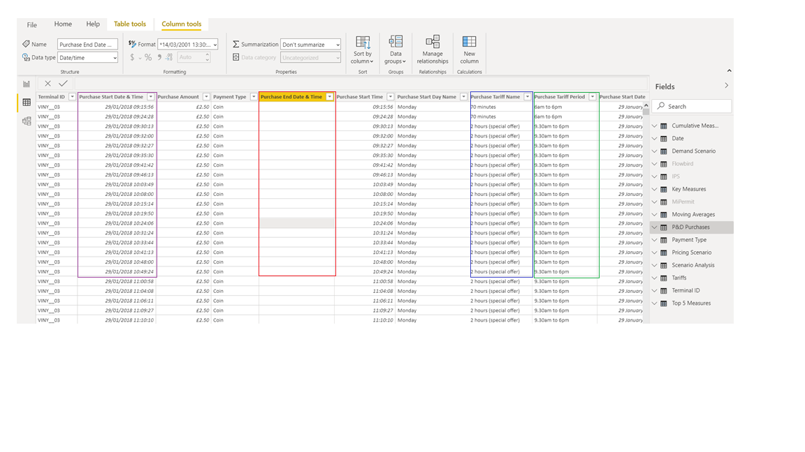
I need DAX that says if the ‘Purchase End Date and Time’ are blank, then look at the ‘Purchase Start Date and Time’ and add the number of hours/mins from the ‘Purchase Tariff Name’ but ensure that it falls within the ‘Purchase Tariff Period’. So if somebody parks and buys a ticket at 17:30 for the 2 hour (special offer) the Purchase end time would be 18:00 and not 19:30.

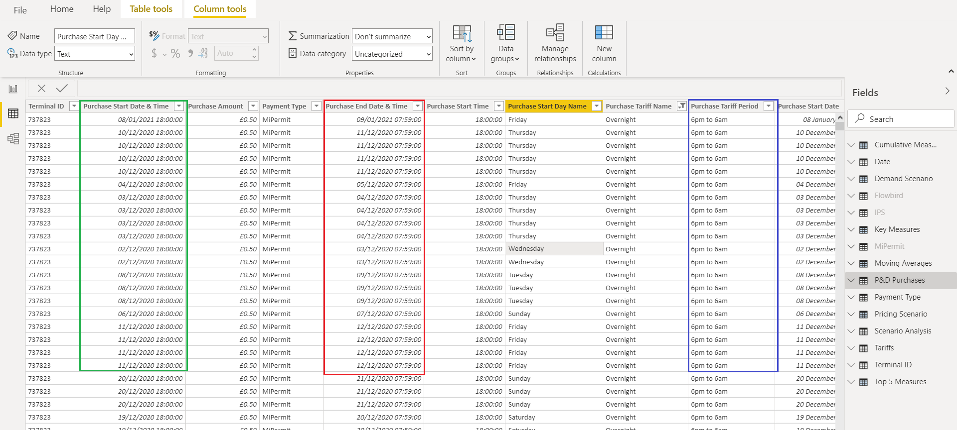

The other issue I face is with the way that we receive data from external agencies. In this scenario, The Purchase Start Date and Time are correct, but he Purchase End Date and Time are showing as 2 hours ahead of the Tariff Period. Can a DAX be written to compensate for this?

