I am trying to recreate a Tableau report in Power BI. Not sure how to handle the dates. In Tableau, I have a calc that adds the revenue for Saturday, Sunday and Monday and shows as all in the Monday date. Thus, in my views I have five data points for Monday thru Friday where Monday revenue is (Sat+Sun+Mon) and then Tues. rev, Weds. rev, Thurs rev and Fri rev.

In Tableau, the calc is just moving the days Sat. to Mon. and Sun. to Mon.:
DATE(IF DATEPART("weekday",[Date])=1 THEN DATEADD("day", 1, [Date])
ELSEIF DATEPART("weekday",[Date])=7
THEN DATEADD("day", 2, [Date])
ELSE [Date]
END)

The graph in the pbix with Sat. and Sun. data rolled into Monday is supposed to look like this view from my Tableau report:
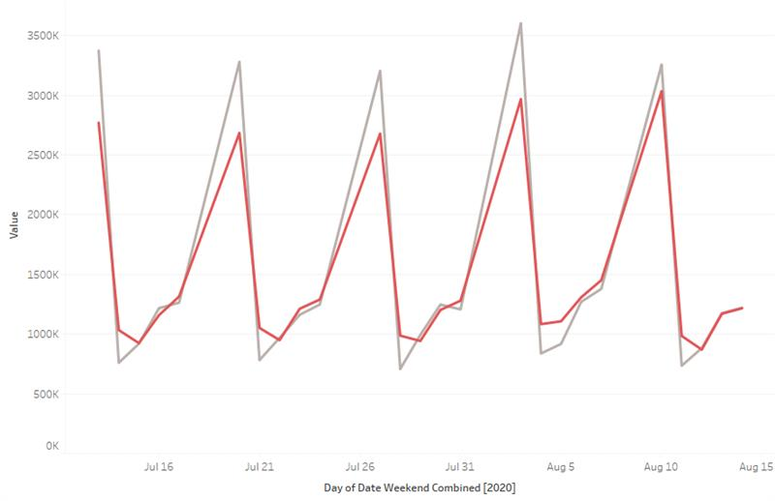

If the Sat. and Sun. data is not rolled into Monday the graph looks like this (what it looks like in the pbix test file I posted):
