In FromFolder Query
Action Line Invoke Custom Fuction1 I get the following

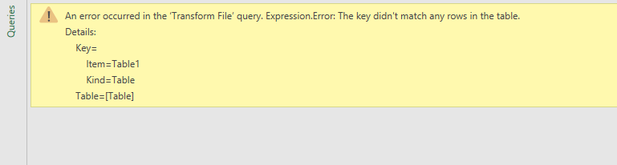

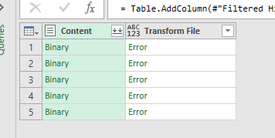

FromFolder code

let
Source = Folder.Files(FileFolderLocation),
#"Removed Other Columns" = Table.SelectColumns(Source,{"Content"}),
#"Filtered Hidden Files1" = Table.SelectRows(#"Removed Other Columns", each [Attributes]?[Hidden]? <> true),
#"Invoke Custom Function1" = Table.AddColumn(#"Filtered Hidden Files1", "Transform File", each #"Transform File"([Content])),
#"Removed Other Columns1" = Table.SelectColumns(#"Invoke Custom Function1", {"Transform File"}),
#"Expanded Table Column1" = Table.ExpandTableColumn(#"Removed Other Columns1", "Transform File", Table.ColumnNames(#"Transform File"(#"Sample File"))),
#"Changed Type" = Table.TransformColumnTypes(#"Expanded Table Column1",{{"Date", type date}, {"In/Out", type text}, {"Name", type text}})
in
#"Changed Type"

