Show short Month Name on clustered chart when Relative date is used for CY PY
I have 4 different visuals which needs to show Short Month (Jan, Feb, Mar etc.) Only. When I remove the Year, it gives me a “can’t display visual” as show in the screenshot below.

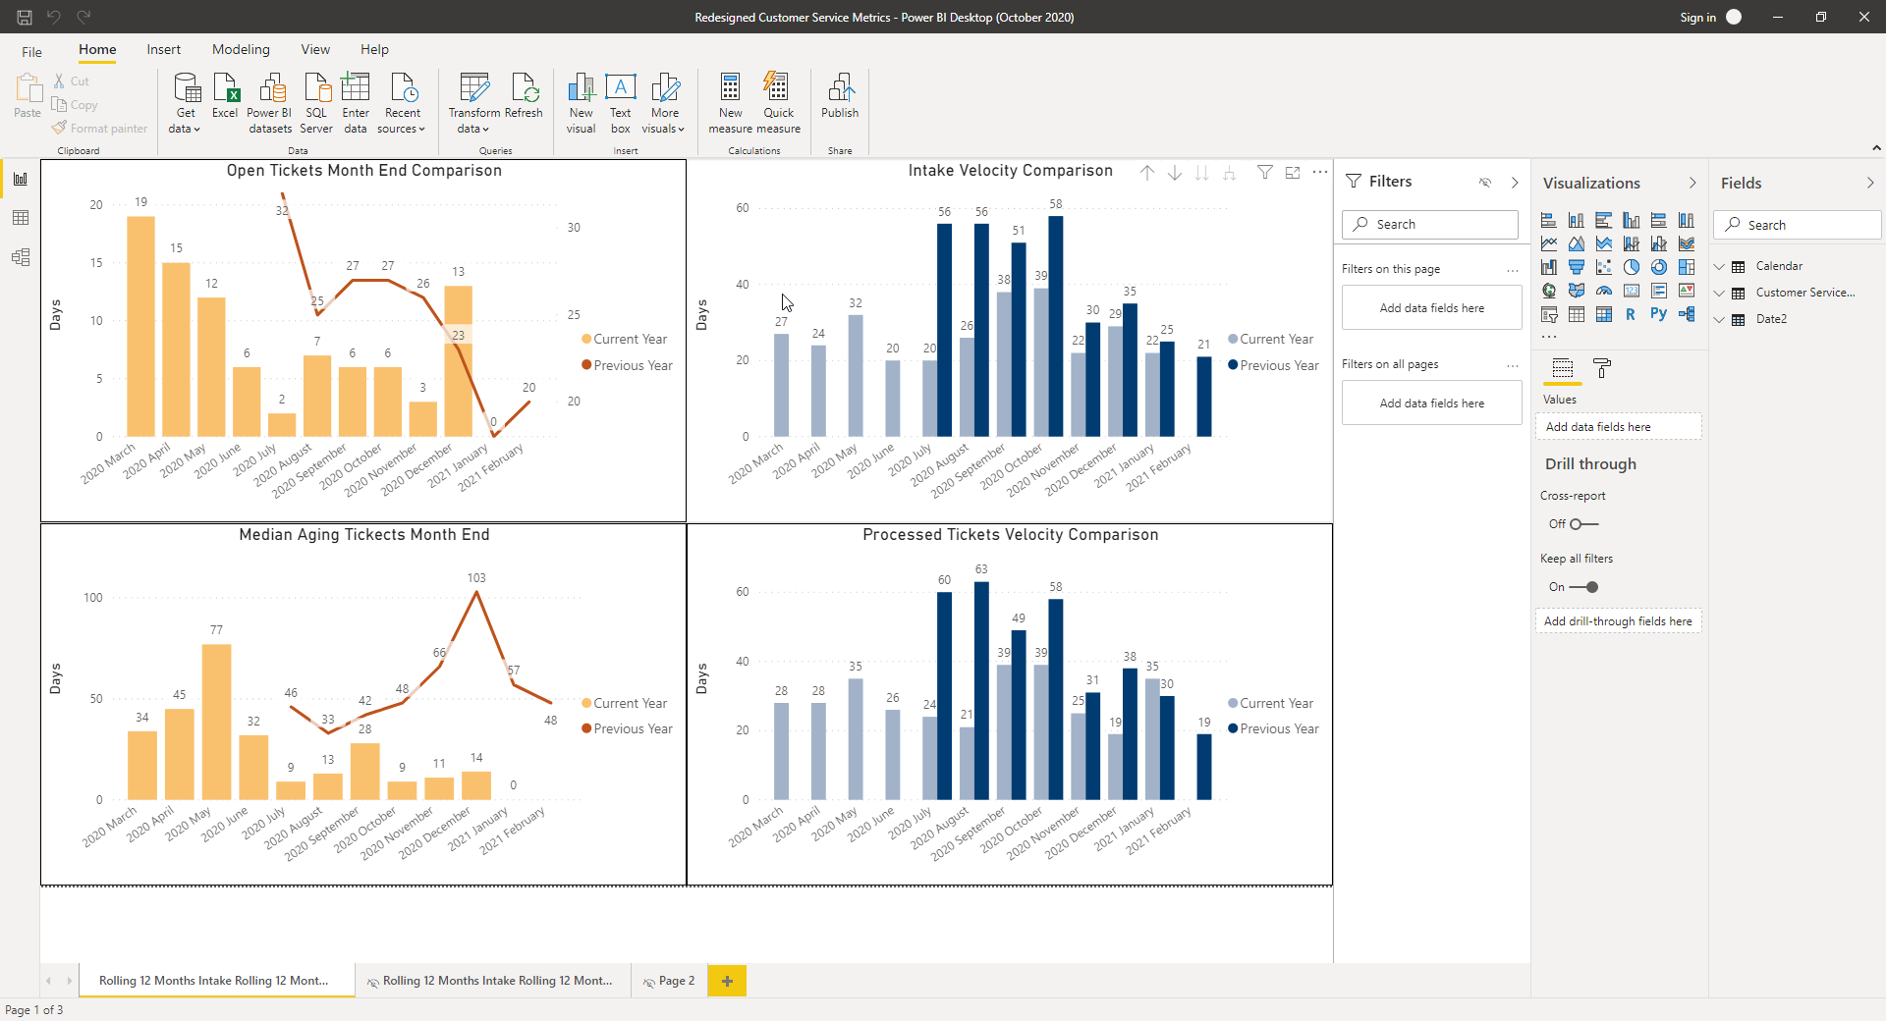
Message displayed when I try to Drill Down to Month Only
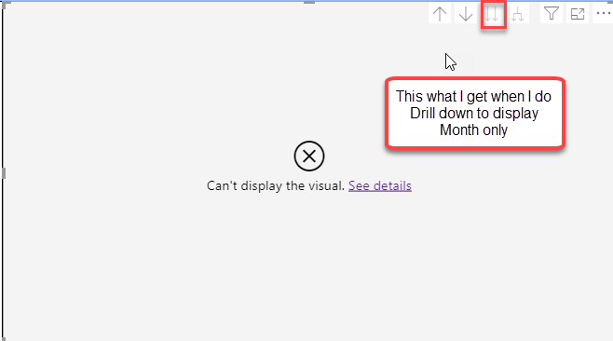

This shows what I have now on the visual showing on X-Axis (Year-Long-Month) and I only want (Short Month) on X-Axis.
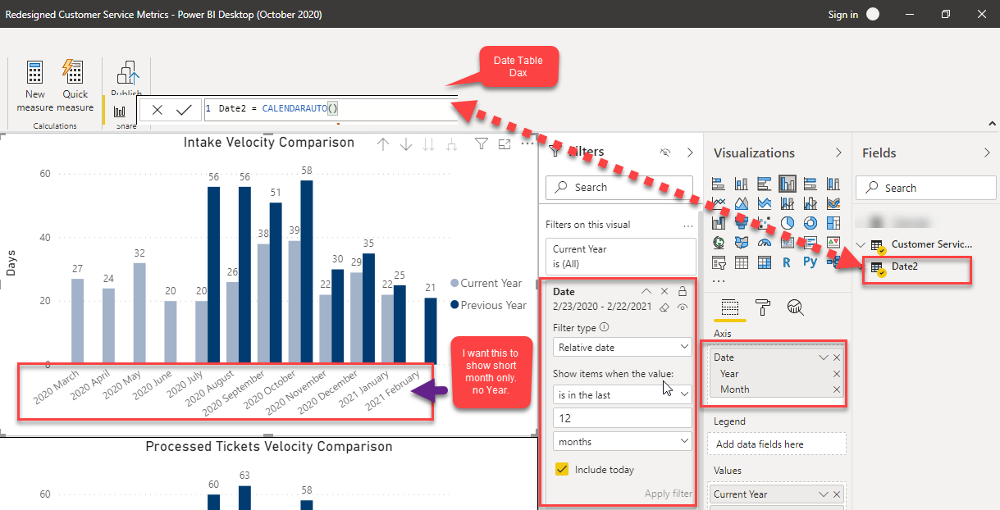

For Date table I used the Dax shown below
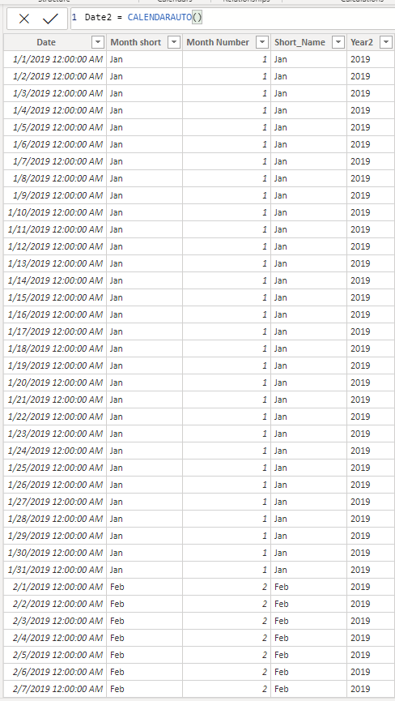

This is my Fact Table
