**Power BI – Issue: Connecting Excel to Power BI ProService**

*From Microsoft Documentation:*

* [https://docs.microsoft.com/en-us/power-bi/collaborate-share/service-analyze-in-excel](https://na01.safelinks.protection.outlook.com/?url=https%3A%2F%2Fdocs.microsoft.com%2Fen-us%2Fpower-bi%2Fcollaborate-share%2Fservice-analyze-in-excel&data=04%7C01%7C%7C8e02ac9bcd2e4cf6222708d95b5bcb73%7C84df9e7fe9f640afb435aaaaaaaaaaaa%7C1%7C0%7C637641272076989770%7CUnknown%7CTWFpbGZsb3d8eyJWIjoiMC4wLjAwMDAiLCJQIjoiV2luMzIiLCJBTiI6Ik1haWwiLCJXVCI6Mn0%3D%7C1000&sdata=xu%2FsRkR6C2gHB0kPO23pLcg02P9ViaGYA7ZtedyFNdA%3D&reserved=0)
* Selected image from the above documentation:
* 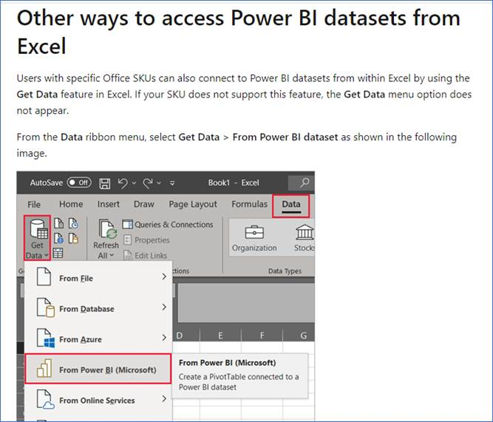

*However, from my desktop Excel:*

* 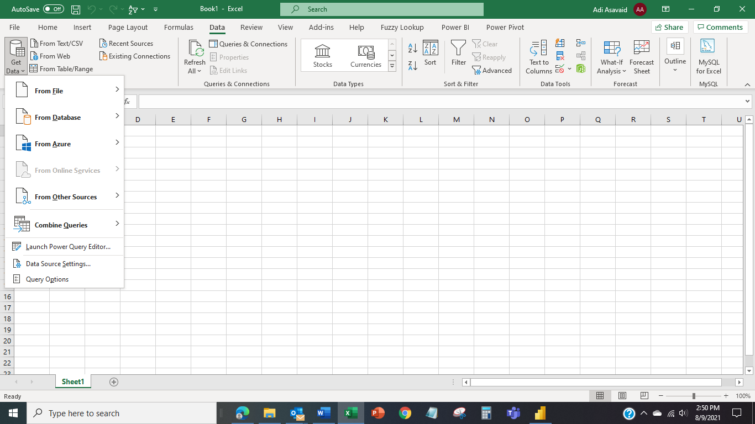

I do not have the same options in my Excel for ‘Data’ option as shown in the documentation.

Requested Microsoft Support on the above observation.

Microsoft Support on 20210810 informed me that this feature is available only in Office 365 Professional version and not Office 365 Family version.

Currently there are three versions of Microsoft 365:

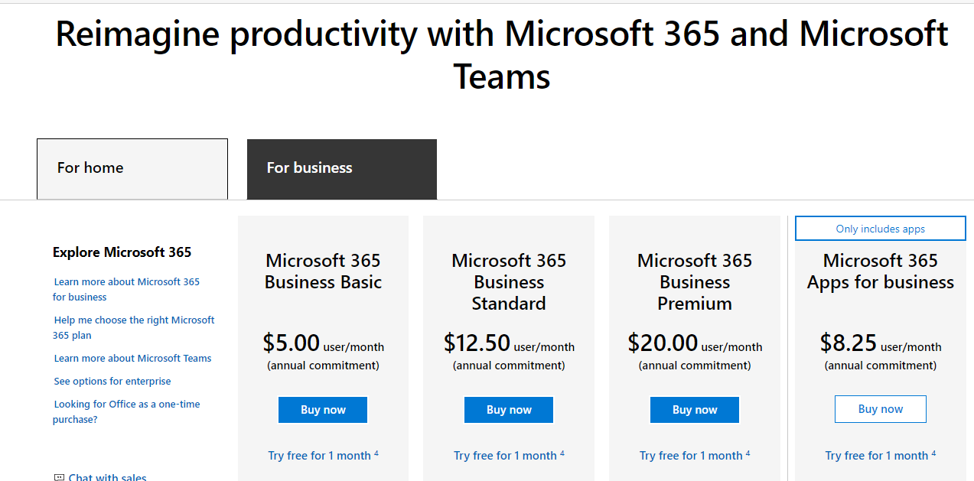

I am trying to find out which is the minimum version which will the option in Excel as shown above.

Any additional help is most welcome.