The below are the steps what I have done for this project.

I have used 2 calendar tables by name

And main table name is REM_ROLE_ACCESS_AUDIT_DATA_RPT

Users are coming from the column - FULL_NAME

Roles are coming from the column – Role

We have reviewer column as well in this table and we need to show in the table. Name of the column is Reviewer

LiveDate – Current period

Comparision_LiveDate – Prior period

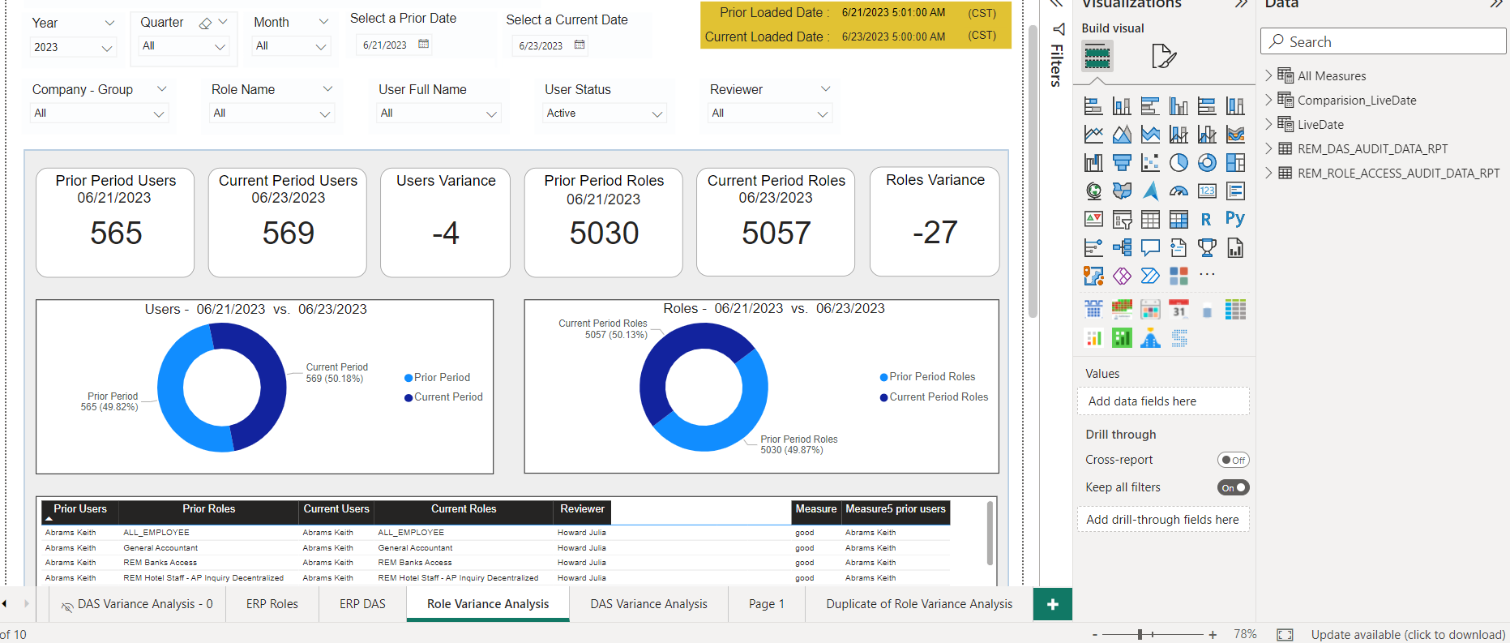

I have counted no of prior users and prior roles by selecting date from Comparision_Livedate from a slicer visual. The measures for prior users and prior roles are as follows

SD P3 Prior Period Users =

var _MINDATE = MIN(Comparision_LiveDate[Date])

var b = CALCULATE([P3 Prior Period Users],TREATAS({_MINDATE},Comparision_LiveDate[Date]))

RETURN

DIVIDE(b,[SD P3 Normalisation Factor])

P3 Prior Period Users = var a = CALCULATE([Current Period Users],ALL(LiveDate),USERELATIONSHIP(LiveDate[Date],Comparision_LiveDate[Date]))*[Normalization Factor]

var b = IF(ISBLANK(a),0,a)

return b

Current Period Users = var a = CALCULATE(DISTINCTCOUNTNOBLANK(REM_ROLE_ACCESS_AUDIT_DATA_RPT[FULL_NAME]),LiveDate[DateID],REM_ROLE_ACCESS_AUDIT_DATA_RPT[DateID_RLD])

var b = IF(ISBLANK(a),0,a)

return b

Normalization Factor = COUNTROWS ( 'LiveDate' ) / COUNTROWS ( 'Comparision_LiveDate' )

SD P3 Normalisation Factor =

var _MINDATE = MIN(Comparision_LiveDate[Date])

var b = CALCULATE([Normalization Factor],TREATAS({_MINDATE},Comparision_LiveDate[Date]))

RETURN

b

so the same measures are repeated for the roles as well by taking column of Role from the same table.

Now I have taken table visual where

Prior users – Full_Name column

Prior roles – Roles

Current users – Full_Name Copy column( I have duplicated the same Full Name column)

Current roles – Roles Copy (I have duplicated the same role column)

Reviewer – reviwer column from the Rem_Role_Access_Audit_Data_RPT table

RoleCode – RoleCode column is from the Rem_Role_Access_Audit_Data_RPT table where it is used to have different rolecodes but I have formatted this column by color white so that the end user will not see the data of it in the table visual.

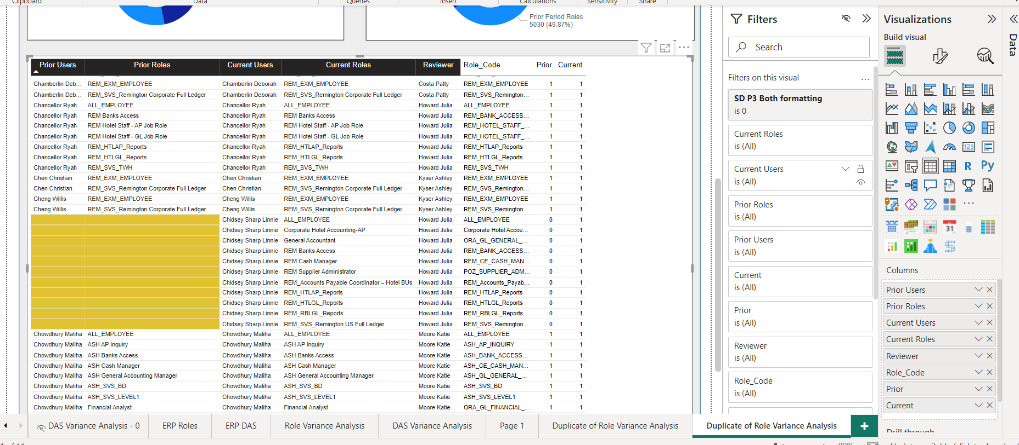

Measures I have taken here -

SD P3 Prior Period Users – renamed as Prior which has 0,1,2 in its value

SD P3 Current Period Users – renamed as current which has 0,1,2 in its value.

But I again I got issue because of reviewer so I created a measure called SD P3 Both formatting and I used this measure in filter panel of table visual to 0

SD P3 Both formatting =

IF([SD P3 Count Role Role] = 0 && [SD P3 Count Roles Role Current]  = 0,1,0)

SD P3 Count Role Role =

var _MINDATE = MIN(Comparision_LiveDate[Date])

RETURN

CALCULATE([Count Role Role],TREATAS({_MINDATE},Comparision_LiveDate[Date]),ALL(LiveDate),USERELATIONSHIP(LiveDate[Date],Comparision_LiveDate[Date]))*[Normalization Factor]

SD P3 Count Roles Role Current =

var _MINDATE = MIN(LiveDate[Date])

RETURN

CALCULATE([Count Roles Role Current],TREATAS({_MINDATE},LiveDate[Date]))

Count Role Role = var a = CALCULATE(COUNT(REM_ROLE_ACCESS_AUDIT_DATA_RPT[ROLE - Copy]),ALL(LiveDate),USERELATIONSHIP(LiveDate[Date],Comparision_LiveDate[Date]))*[Normalization Factor]

var b = IF(ISBLANK(a),0,a)

return b

Count Roles Role Current = var a = CALCULATE(COUNT(REM_ROLE_ACCESS_AUDIT_DATA_RPT[ROLE]),LiveDate[DateID],REM_ROLE_ACCESS_AUDIT_DATA_RPT[DateID_RLD])

var b = IF(ISBLANK(a),0,a)

return b

Now in table visual I started doing conditional formatting of prior users, prior roles and current users, current roles based on the Prior(SD P3 Prior Period Users) values 0 and 1

The column prior users, prior roles to same font and background color yellow where Prior(SD P3 Prior Period Users) value is 0.

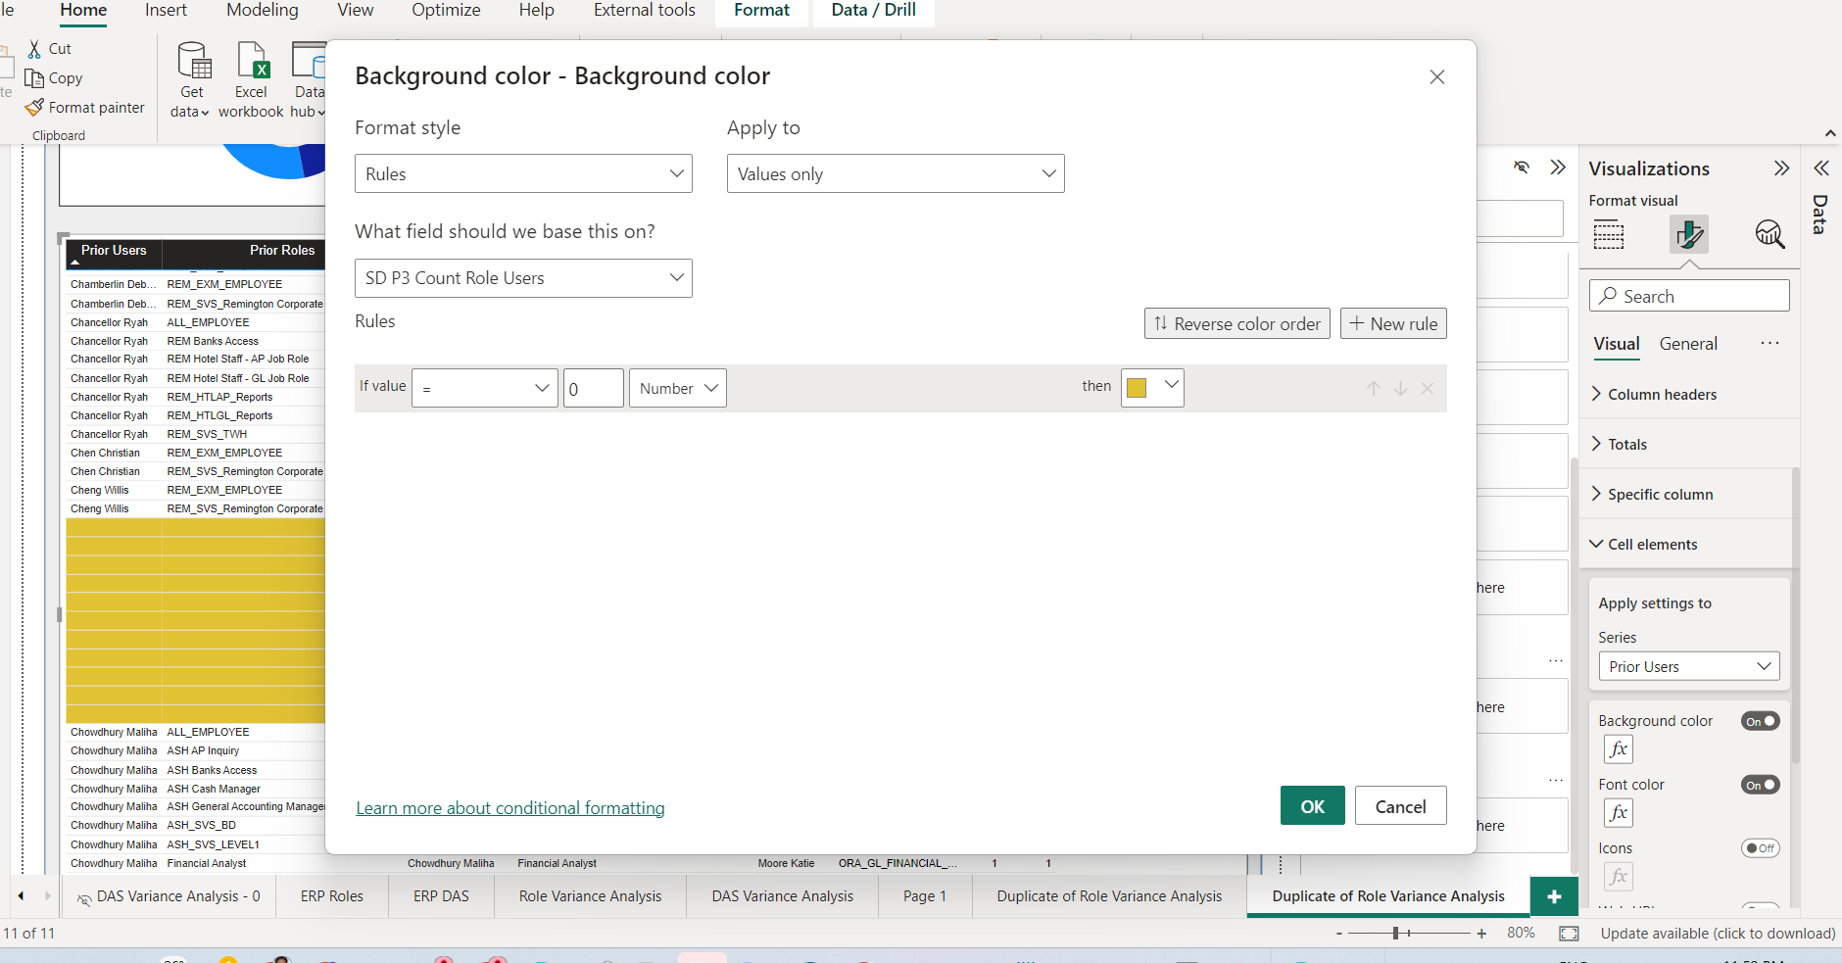

In the same way for the Current users and current roles I have done by using measure Current(SD P3 Current Period Users) values 0 and 1

The column current users, current roles to same font and background color yellow where Current(SD P3 Current Period Users) value is 0.

Later in table visual I have made font color to white for the following columns of - Prior(SD P3 Prior Period Users),

Current(SD P3 Current Period Users),

Role_Code

But now when end user is trying to export this table by excel the table has all the columns and measures are showing so the end user wants to manually edit the prior users and prior roles values to be deleted when Prior(SD P3 Prior Period Users) is zero and same for current as well but end user asked me to make blank in power bi table visual itself so that they need not to do those steps manually.

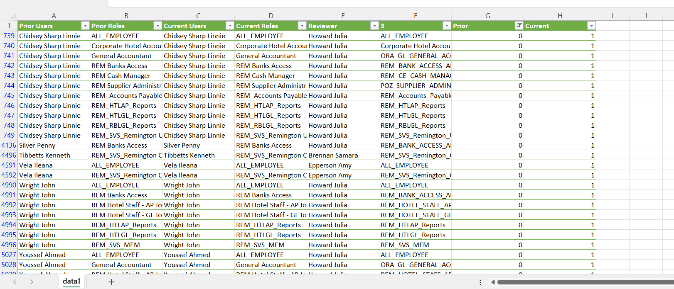

Here I have struck to go further.

Later I have tried again in many ways and I have written a measure called

Measure5  prior users = IF([SD P3 Prior Period Users] >0,SUMMARIZECOLUMNS(REM_ROLE_ACCESS_AUDIT_DATA_RPT[FULL_NAME]),BLANK())

Measure5 Prior roles = IF([SD P3 Prior Period Roles] > 0,SUMMARIZECOLUMNS(REM_ROLE_ACCESS_AUDIT_DATA_RPT[ROLE]),BLANK())

Measure5 Current users = IF([SD P3 Current Period Users] > 0,SUMMARIZECOLUMNS(REM_ROLE_ACCESS_AUDIT_DATA_RPT[FULL_NAME]),BLANK())

Measure5 Current roles = IF([SD P3 Current Period Roles] >0,SUMMARIZECOLUMNS(REM_ROLE_ACCESS_AUDIT_DATA_RPT[ROLE]),BLANK())

But again I have faced issue here where I cant get values for full_name and Role when the

Prior(SD P3 Prior Period Users) is 1 and at that condition when Current(SD P3 Current Period Users) is 0. As Prior is 1 then prior users and prior roles need to be shown the column values of Full_Name and Role but its showing Blank. So now again I have struck here

;

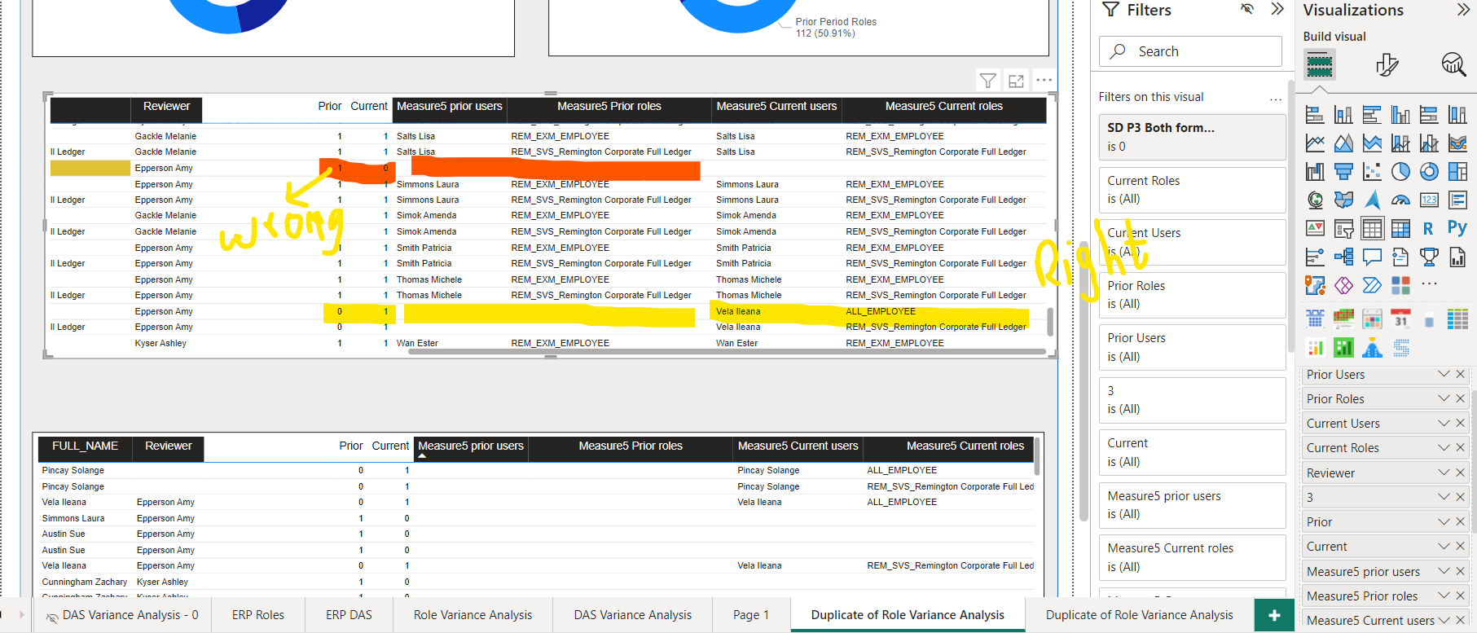

Now can you help me after this please.

So now where I need to make changes so I can get values when prior is 1 and current is 0 at this condition the prior users and Prior roles are to be shown the values from the column Full_Name and Role. I hope I explained neatly if still anything do I need to explain please ask me I will and help me in this to solve this issue.

I am sharing the model view as well

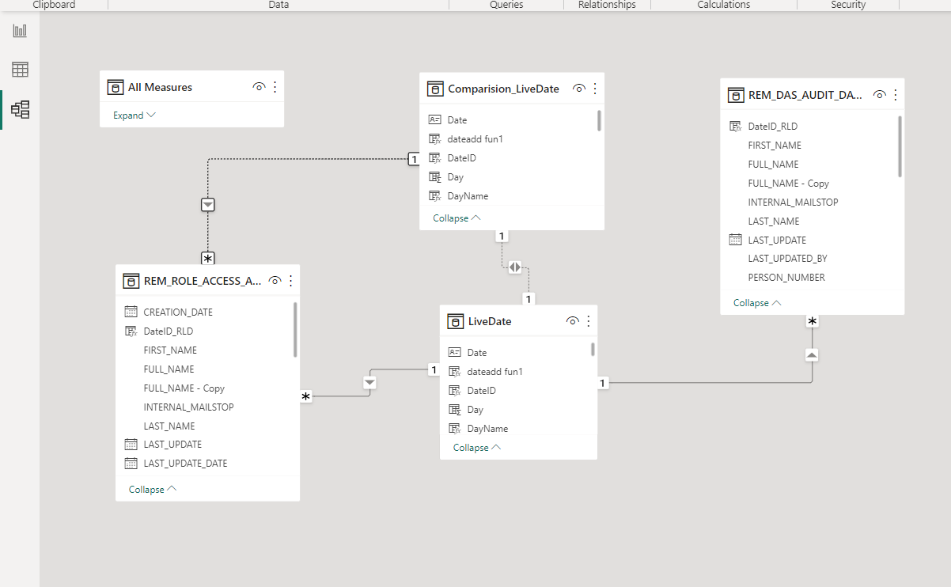

Please help me in solving this issue. Thanks in advance.