Enterprise DNA Data Analysis Workout 005
Brian Julius
4/29/23

Setup Chunk
#| label: setup #| include: false
library(tidyverse)
library(ggpubr)
library(ggthemes)
tips <- read_csv("https://raw.githubusercontent.com/guipsamora/pandas_exercises/master/07_Visualization/Tips/tips.csv", col_types = cols(...1 = col_skip()))
tips$day <- factor(tips$day, levels = c("Thur", "Fri", "Sat", "Sun"))
tips$time <- factor(tips$time, levels = c("Lunch", "Dinner"))
tips$size <- factor(tips$size, levels = c( "1", "2", "3", "4", "5", "6"))
##Structure of “tips” file to be used in analysis:

Note: Q1 incorporated in file import step
#| label: data overview
#| echo: false
knitr::kable(head(tips, 5))
total_bill | tip | sex | smoker | day | time | size
16.99 | 1.01 | Female | No | Sun | Dinner | 2
10.34 | 1.66 | Male | No | Sun | Dinner | 3
21.01 | 3.50 | Male | No | Sun | Dinner | 3
23.68 | 3.31 | Male | No | Sun | Dinner | 2
24.59 | 3.61 | Female | No | Sun | Dinner | 4

Q2: Plot the total_bill column histogram
gghistogram(tips,
x="total_bill",
fill = "lightblue",
bins = 15,
rug = TRUE,
add = "mean",
xlab = "Total Bill",
ylab = "Count",
main = "Distribution of Total Bill"
)
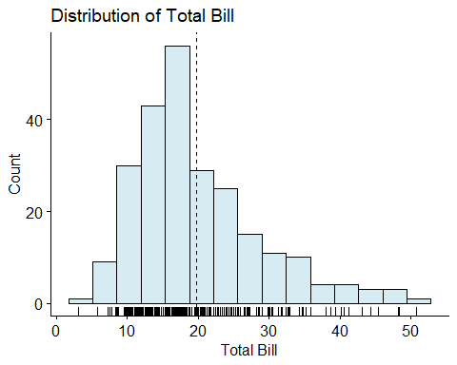

Q3: Create a scatterplot presenting the relationship between total_bill and tip
ggscatter(tips,
x="total_bill",
y="tip",
xlab = "Total Bill",
ylab = "Tip",
conf.int = TRUE,
add = "reg.line",
add.params = list(linetype = "solid", color = "red"),
main = "Relationship Between Total Bill and Tip"
)
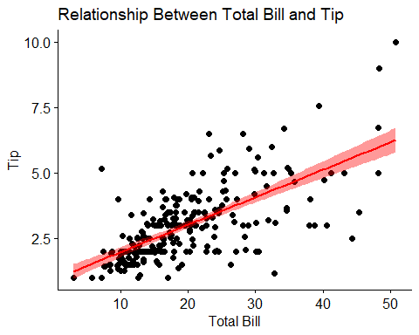

Q4: Create one image with the relationship of total_bill, tip and size
ggscatter(data = tips,
x = "total_bill",
y = "tip",
xlab = "Total Bill",
palette = rev( c("#d73027","#fc8d59","#fee090","#e0f3f8","#91bfdb","#4575b4")),
ylab = "Tip",
color = "size",
size = "size",
main = "Relationship of Total Bill, Tip and Size"
) + guides(size = guide_none()) + labs(color = "Size") + theme(legend.position = "bottom")
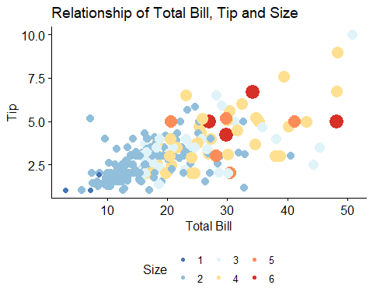

Q5: Present the relationship between days and total_bill value, differ the dots by sex
ggstripchart(data = tips,
palette = c("red", "blue"),
color = "sex",
x = "day",
y = "total_bill",
xlab = "",
ylab = "Total Bill",
main = "Distribution of Total Bill by Day"
) + labs(color = "Gender") + theme(legend.position = "bottom")
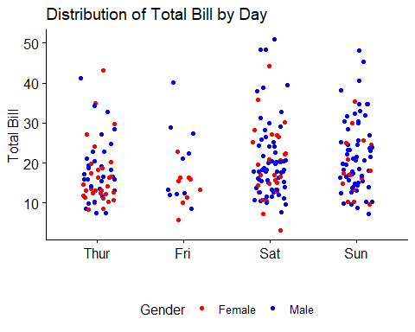

Q6: # Create a box plot presenting the total_bill per day differentiated by time
ggboxplot(data = tips,
x = "day",
y = "total_bill",
fill = "time",
xlab = "",
ylab = "",
main = "Distribution of Total Bill by Day and Time"
) + labs(fill = "Meal") + theme(legend.position = "bottom")
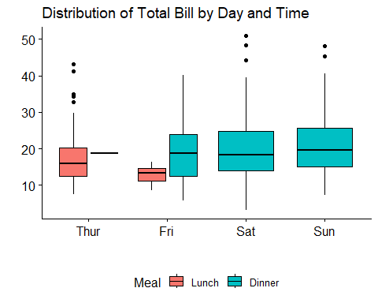

Q7: Create two histograms (side by side) of the tip value based for Lunch and Dinner
gghistogram(tips,
x="total_bill",
fill = "time",
bins = 15,
rug = TRUE,
main = "Distribution of Total Bill by Time",
facet.by = "time",
xlab = "",
ylab = ""
) + labs(fill = "Meal") + theme(legend.position = "none")
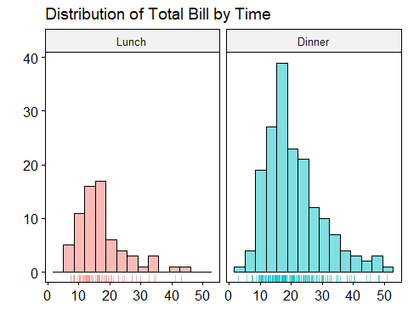

Q8: Create two scatterplots (Male and Female) presenting the total_bill value and tip relationship, differing by smoker/non-smoker
ggscatter(tips,
x="total_bill",
y="tip",
conf.int = TRUE,
palette = c("cyan", "navyblue"),
color = "smoker",
facet.by = "sex",
add = "reg.line",
xlab = "Total Bill",
ylab = "Tip",
add.params = list(linetype = "solid", color = "red"),
main = "Tip by Total Bill by Gender and Smoker"
) + labs(color = "Smoker") + theme(legend.position = "bottom")
