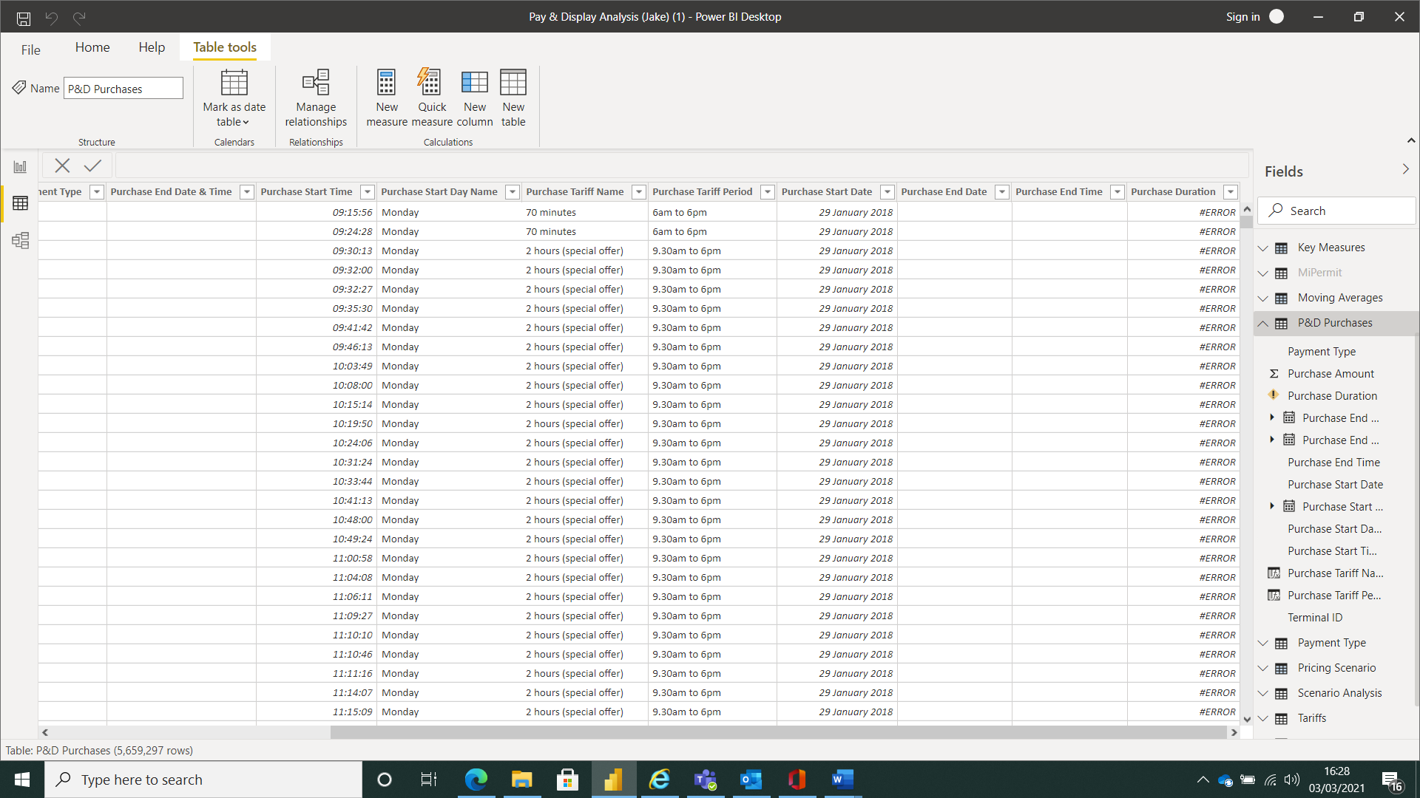
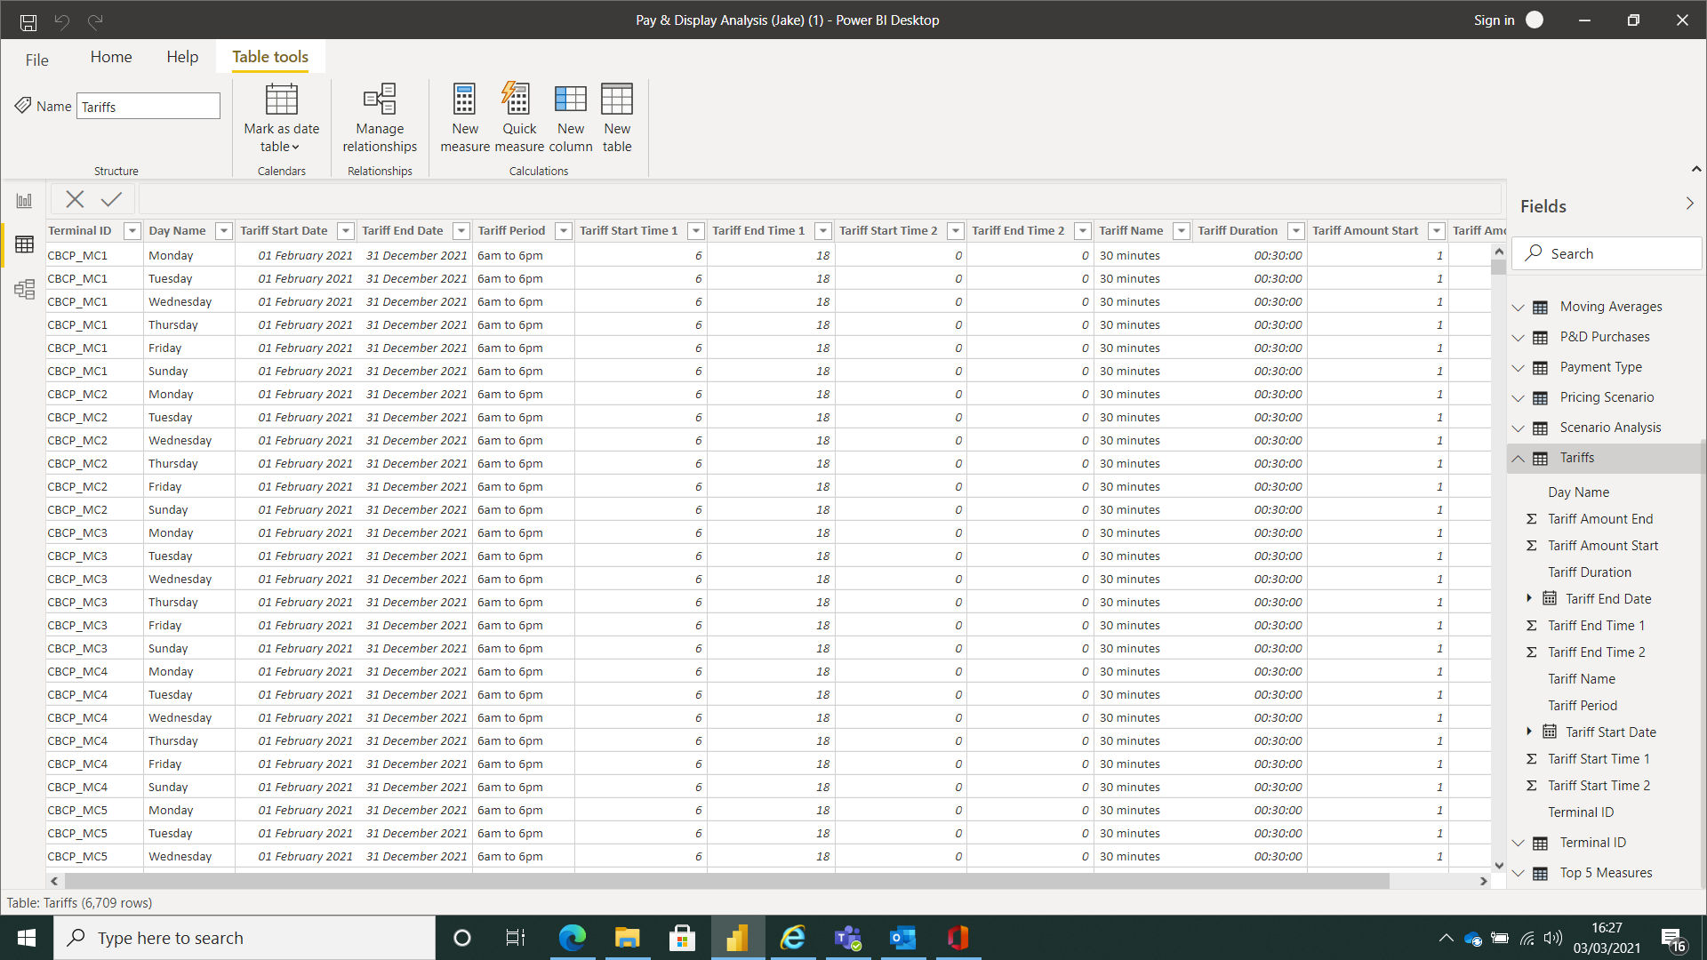

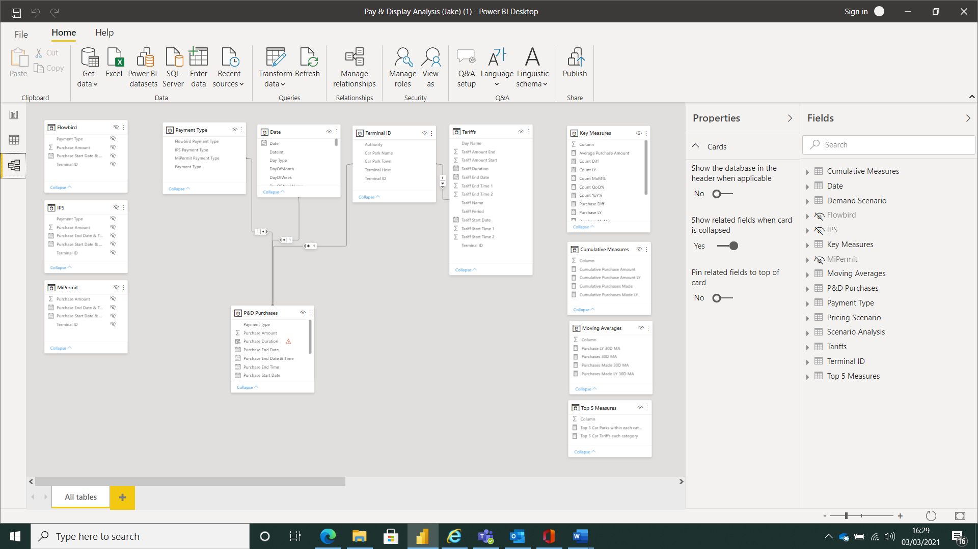

Purchase Duration = CALCULATE(VALUES('Tariffs'[Tariff Duration]),FILTER(Tariffs,'P&D Purchases'[Terminal ID]='Tariffs'[Terminal ID ]&&'P&D Purchases'[Purchase Start Day Name]='Tariffs'[Day Name]&&'P&D Purchases'[Purchase Start Date & Time]>='Tariffs'[Tariff Start Date]&&'P&D Purchases'[Purchase Start Date & Time]<='Tariffs'[Tariff End Date]&&'P&D Purchases'[Purchase Amount]>='Tariffs'[Tariff Amount Start]&&'P&D Purchases'[Purchase Amount]<='Tariffs'[Tariff Amount End]&&('P&D Purchases'[Purchase Start Time]>='Tariffs'[Tariff Start Time 1]*(1/24)&&'P&D Purchases'[Purchase Start Time]<'Tariffs'[Tariff End Time 1]*(1/24)||'P&D Purchases'[Purchase Start Time]>='Tariffs'[Tariff Start Time 2]*(1/24)&&'P&D Purchases'[Purchase Start Time]<'Tariffs'[Tariff End Time 2]*(1/24))))

